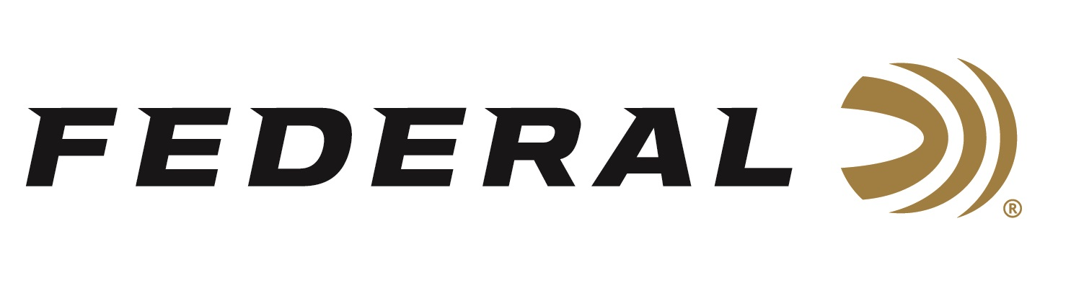

FOR IMMEDIATE RELEASE

**Federal Shooter Mein Captures Event Title at South Central Regional**

**ANOKA, Minnesota –** **September 16, 2025 –** Federal Ammunition congratulates Derrick Mein on winning the Super Sport event at the South Central Regional competition. The event, held at Covey Rise Gun Club in Husser, Louisiana, from September 10-14, 2025, drew 632 of the best NSCA competitors over the week.

The two-time Olympian took home the High Over All honors in the Super Sport event, hitting an impressive 96 out of 100 targets on a challenging course design, and besting the group of 499 shooters. Mein also finished Runner-Up in the 5-Stand over another strong field of nearly 360 fellow competitors.

Mein loads his shotgun with Federal’s Gold Medal Paper shotshells when competing at NSCA events. With an exclusive paper hull design, high-antimony lead shot, and a two-piece wad that delivers more uniform patterns, Mein, like others, trusts in the gold standard set by Federal’s Gold Medal Paper shotshells.

“I contribute my continued success to the quality and consistency of the Federal Premium® Gold Medal Papers that I rely on,” said Mein. “Even when I’m not perfect, they are, and they help me break those few extra targets it takes to win.”

Federal Ammunition products are available at dealers nationwide and online. For more information on all Federal products, visit [www.federalpremium.com](http://www.federalpremium.com).

**Press Release Contact:** JJ Reich

Senior Manager – Press Relations

E-mail: media@tkghunt.com

**About Federal Ammunition**

Federal, headquartered in Anoka, MN, is an ammunition brand of The Kinetic Group, owned by CSG, a globally diversified industrial group based in Prague (Czech Republic). From humble beginnings nestled among the lakes and woods of Minnesota, Federal Ammunition has evolved into one of the world's largest producers of sporting ammunition. In 1922, founding President Charles L. Horn paved the way for our success. Today, Federal carries on Horn's vision for quality products and services with the next generation of outdoorsmen and women. We maintain our position as experts in the science of ammunition production. Every day, Federal manufactures products to enhance our customers' shooting experience while partnering with the conservation organizations that protect and support our outdoor heritage. Federal offers thousands of options in our Federal Premium® and standard Federal® lines, which is what makes it the most complete ammunition company in the business and helps it provide customers with a choice no matter what the pursuit.